**Covedale Center for the Performing Arts**

**2025 – 2026 Marquee Subscription Season**

**at the**

**Arnold and Mary Jo Barnett Performance Hall**

**ON SALE NOW!!!!**

Enjoy great theatrical entertainment – at a great price! The subscriber rate is $32.00 per ticket ($128.00 for 4 show package). The Covedale has plenty of subscription seats available with excellent views of the stage! New subscribers are encouraged to get their seats now for best seating choices. Visit [www.CLPShows.org](http://www.clpshows.org) for more information all year long.

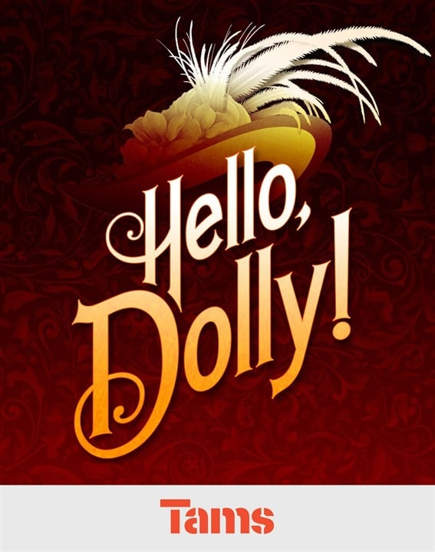

**Hello, Dolly! October 9 – November 2, 2025**

Book by Michael Stewart; Music and Lyrics by Jerry Herman

Based on the play The Matchmaker by Thornton Wilder

This Musical adaptation of Thornton Wilder’s hit play, *The Matchmaker*, bursts with humor, romance, energetic dance and some of the greatest songs in musical theatre history, including “So Long Dearie”, “It Takes a Woman”, “Put On Your Sunday Clothes”, “It Only Takes A Moment” and the exuberant title song “Hello Dolly”. The romantic and comic exploits of Dolly Gallagher Levi, turn-of-the-century matchmaker and “woman who arranges things,” is one of the greatest musicals of all time!

# Irving Berlin's Holiday InnHoliday Inn December 4 – December 28, 2025

# *Music and Lyrics by Irving Berlin; Book by Gordon Greenberg and Chad Hodge* Based on the film from Universal Pictures

Irving Berlin's Holiday Inn tells the story of Jim, who leaves the bright lights of show business behind to settle down on his farmhouse in Connecticut... but life just isn't the same without a bit of song and dance. Jim's luck takes a spectacular turn when he meets Linda, a spirited schoolteacher with talent to spare. Together they turn the farmhouse into a fabulous inn with dazzling performances to celebrate each holiday, from Thanksgiving to the Fourth of July. But when Jim's best friend Ted tries to lure Linda to Hollywood to be his new dance partner, will Jim be able to salvage his latest chance at love? Based on the classic film, this joyous musical features thrilling dance numbers, laugh-out-loud comedy and a parade of Irving Berlin hits, including "Blue Skies," "Easter Parade," "Steppin' Out With My Baby," "Heat Wave," "White Christmas," "Be Careful, It's My Heart," "Cheek to Cheek," "Shaking the Blues Away" and many more!

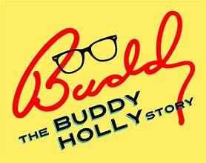**Buddy - The Buddy Holly Story**

**January 22 – February 15, 2026**

*By arrangement with Alan Janes; Written by Alan Janes*

*Buddy – The Buddy Holly Story* Tells the true story of Buddy’s meteoric rise to fame, from the moment in 1957 when ‘That’ll Be The Day’ hit the airwaves until his tragic death less than two years later on “The Day The Music Died”. Featuring over 20 of Buddy Holly’s greatest hits including: “That’ll be the Day”, “Peggy Sue”, “Everyday”, “Oh Boy”, “Not Fade Away”, “Rave On”, “Chantilly Lace” and many more! The incredible legacy of the young man with glasses, whose musical career spanned an all too-brief period during the golden days of rock & roll, continues to live on in Buddy.

**Legally Blonde, The Musical**

**March 12 – April 5, 2026**

*Booky by Heather Hack; Music and Lyrics by Laurence O’Keefe and Nell Benjamin. Based on the novel by Amanda Brown and the Metro Goldwyn-Mayer motion picture*

Legally Blonde The Musical, follows the transformation of Elle Woods as she tackles stereotypes and scandal in pursuit of her dreams. Action-packed and exploding with memorable songs and dances, Elle Woods appears to have it all. Her life is turned upside down when her boyfriend, Warner, dumps her so he can attend Harvard Law. Determined to get him back, Elle ingeniously charms her way into the prestigious law school. While there, she struggles with peers, professors and her ex. With the support of some new friends, though, Elle quickly realizes her potential and sets out to prove herself to the world. This one is so much fun, it should be illegal!

IMPORTANT DATES:

Subscriptions on sale Thursday, December 5, 2024

Subscription renewal deadline is Friday, August 15, 2025

Subscription package tickets will be mailed Friday, August 29, 2025

Single tickets go on sale, Tuesday, September 2, 2025

Single ticket pricing: $37.00 for Adults; $34 for Students and Seniors

***Due to availability, season titles are subject to change.***

***Please note performance times:*** ***Thursday 7:30 pm; Friday 7:30 pm; Saturday 7:30 pm; & Sunday 2:00 pm.***

Complete Performance Date Listing:

**Hello Dolly! Buddy – The Buddy Holly Story**

Thurs. Oct. 9 - Fri. Oct. 10 – Sat. Oct. 11 – Sun. Oct. 12 Thurs. Jan. 22 - Fri. Jan. 23 – Sat. Jan. 24 – Sun. Jan. 25

Thurs. Oct. 16 - Fri. Oct. 17 – Sat. Oct. 18 – Sun. Oct. 19 Thurs. Jan. 29 - Fri. Jan. 30 – Sat. Jan. 31 – Sun. Feb. 1

Thurs. Oct. 23 - Fri. Oct. 24 – Sat. Oct. 25 – Sun. Oct. 26 Thurs. Feb. 5 – Fri. Feb. 6 – Sat. Feb. 7 – Sun. Feb. 8

Thurs. Oct. 30 – Fri. Oct. 31 – Sat. Sept. Nov. 1 – Sun. Nov. 2 Thurs. Feb. 12 – Fri. Feb. 13 – Sat. Feb. 14– Sun. Feb. 15

**Holiday Inn**  **Legally Blonde, The Musical**

Thurs. Dec. 4 – Fri. Dec. 5 – Sat. Dec. 6 – Sun. Dec. 7 Thurs. Mar. 12 – Fri. Mar. 13 – Sat. Mar. 14 – Sun. Mar. 15

Thurs. Dec. 11 – Fri. Dec. 12 – Sat. Dec. 13 – Sun. Dec. 14 Thurs. Mar. 19 – Fri. Mar. 20 – Sat. Mar. 21 – Sun. Mar. 22

Wed. Dec. 17 - Thurs. Dec. 18 – Fri. Dec. 19 – Sat. Dec. 20 – Sun. Dec. 21 Thurs. Mar. 26 – Fri. Mar. 27 – Sat. Mar. 28 – Sun. Mar. 29

Fri. Dec. 26 – Sat. Dec. 27 – Sun. Dec. 28 Thurs. Apr. 2 – Fri. Apr. 3 – Sat. Apr. 4 – * Sun. Apr. 5

For ***Holiday Inn*** – Thurs. #4 subscribers are moved *Sunday April 5, 2026, is Easter

to Wed. Dec. 17th due to the Christmas holiday. We will be performing on Easter Sunday.

**You can purchase OR renew a subscription by one of the following methods:**

* Call the box office @ 513.241.6550
* Mail your subscription order form to: CLP, P.O. Box 5255 Cincinnati, OH 45205
* Log on to: [www.CLPShows.org](http://www.clpshows.org)
* In person at the Covedale or Incline box office ticket counters
* Single tickets go on sale Tuesday, September 2, 2025. $37 for Adults; $34 for Seniors/Students

**Covedale Center for the Performing Arts**

**Seating Chart**

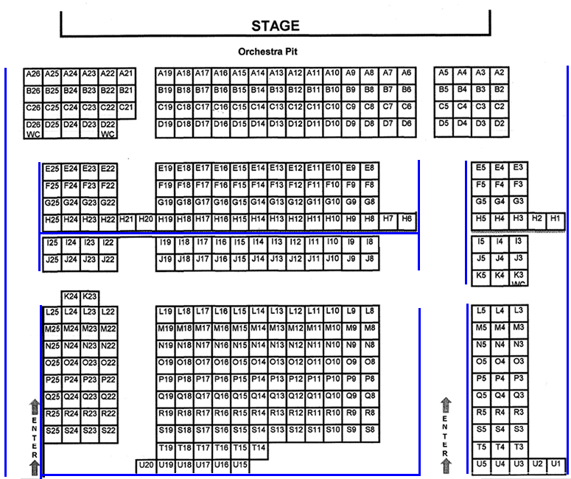



**Don’t Miss Cincinnati Young People’s Theatre’s 43rd Summer!**

**Children of Eden July 24 – August 3, 2025**

*Book by John Caird; Music and Lyrics by Stephen Schwartz*

*Based on a concept by Charles Lisanby; Orchestrations by Bruce Coughlin and Martin Erskine* **Children of Eden**Is presented through special arrangement with Music Theatre International. From musical theatre greats, Stephen Schwartz and John Caird, comes a joyous and inspirational musical about parents, children and faith... not to mention centuries of unresolved family business! An expansive and ambitious musical, the original production used a cast of sixty. Adam, Eve, Noah and the "Father" who created them deal with the headstrong, cataclysmic actions of their respective children. The show ultimately delivers a bittersweet but, inspiring message: that "the hardest part of love... is letting go."

For information on all the shows at all of our great venues, check out: [**www.clpshows.org**](http://www.clpshows.org)

**For Office use only D_____ S_____ U_____**

**Covedale Center for the Performing Arts**

**Subscription Order Form for 2025– 2026 Season**

*(Please fill out completely)*

Name: ________________________________ Email:___________________________________

Address/City/State/Zip: ____________________________________________________________

Home Phone #: __________________________ Alternate #: ____________________________

**SUBSCRIPTION ORDER INFORMATION:**

I would like _____ Marquee series **Subscriptions** @ $128.00 each for a total of……….. $________

*A subscription* ***INCLUDES*** *All Four Season Shows.*

**The Subscription Package features the low, Subscriber - only price of $32.00 per show.**

**DONOR SUPPORT ------------** Diamond Level $1,000.00 and above ________

Platinum Level $ 500.00 and above ________

*Won’t you consider a tax-deductible donation* Gold Level $ 250.00 and above ________

*To help keep CLP growing?* If you have Silver Level $ 100.00 and above ________

*not contributed to our Annual Giving*

*Campaign, you can make a donation now.*

**TOTAL AMOUNT (Subscriptions + Donor Support)** = $ _______________

|  |  |
| --- | --- |
| **PAYMENT OPTION INFORMATION:**  Enclosed is my check made payable to  Cincinnati Landmark Productions: ________  (*Please “X” if check is enclosed*) | **Payment Address:**  Covedale Center for the Performing Arts  P.O. Box 5255  Cincinnati, OH 45205 |
|  |  |

Credit Card Payment: Name on Card: ____________________________________

Credit Card Number: ____________________________________

Expiration Date: ____________________________________

Billing Zip Code: _________________ CVV:______________

**SERIES PERFORMANCE REQUEST:** *(Choose a performance schedule below - one day and one week for series)*

Were you a 2024-25 Marquee Season Subscriber? YES _____ NO ______

__________ Check here if you wish your day and seats to remain the same.

- Renewing Subscribers are guaranteed their same seats, only if they keep the same day and week *AND* renew by the deadline.

_______________ Check here if you would like to change your series choice below.

- Seating changes or upgrades are filled on availability and in the order received.

**DAY AND TIME** **WEEK**

_____ Thursday 7:30 pm  _____ No Preference

_____ Friday 7:30 pm _____ 1st Week of Run

_____ Saturday 7:30 pm _____ 2nd Week of Run

_____ Sunday 2:00 pm _____ 3rd Weed of Run

_____ 4th Week of Run

Please specify wheelchair needs:____________________________________________________

**You can purchase OR renew a subscription by one of the following methods:**

* Call the box office @ 513.241.6550
* Mail your subscription order form to: CLP P.O. Box 5255 Cincinnati, OH 45205
* Log on @ [www.clpshows.org](http://www.clp.org)   
  In person at the Covedale or Incline box office ticket counters